Formula

Formula 1

Enter # of Pool Units (N)] is the number of pool units to add to Result for every D units of Amount in the [Enter Block Size (D)] input field. E.g. if N = 5, D=50:
Amount | $60 | $65 | $119 | $160 | $210
Result = | 5 | 5 | 10 | 15 | 20
Result = [Round Down to Integer for (Transaction Amount / D)] * N
Then apply precision and rounding type handling to the formula 1 result.
Finally result = Award points by Before Cap amount + Award points by after cap amount (if After Cap is available)
Example 1:
Txn Amt = 52.87, N=1, D =1, pool precision = 0, rounding type = Nearest
Formula 1 result = [Round Down to Integer for (52.87 / 1)] * 1 = [Round Down to Integer for (52.87)] *1 = 52* 1 = 52
Then apply precision and rounding type handling to the formula 1 result = 52

Example 2:
Txn Amt = 52.87, N=0.1, D =0.1, pool precision = 0, rounding type = Nearest
Formula 1 result = [Round Down to Integer for (52.87 / 0.1)] * 0.1 = [Round Down to Integer for (528.7)] * 0.1 = 528 * 0.1 = 52.8
Then apply precision and rounding type handling to the formula 1 result = 53.
The finally result = Award points by Before Cap amount + Award points by after cap amount (if After Cap is available)

Formula 2
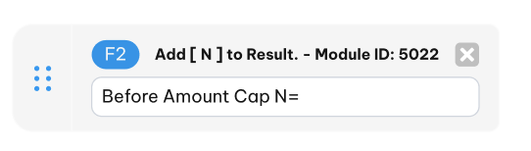
“N” is the number of Pool Units to add to “Result” for every transaction meeting criteria in this Rule.

Formula 3
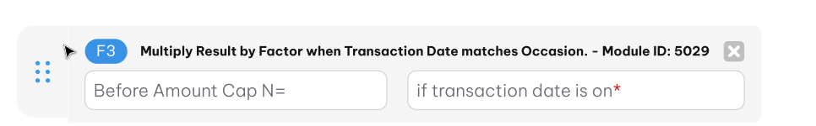
The Result is multiplied by “M” if transaction date matches the selected Event Date(s). Event Date(s) is a multi-select field.

Formula 4
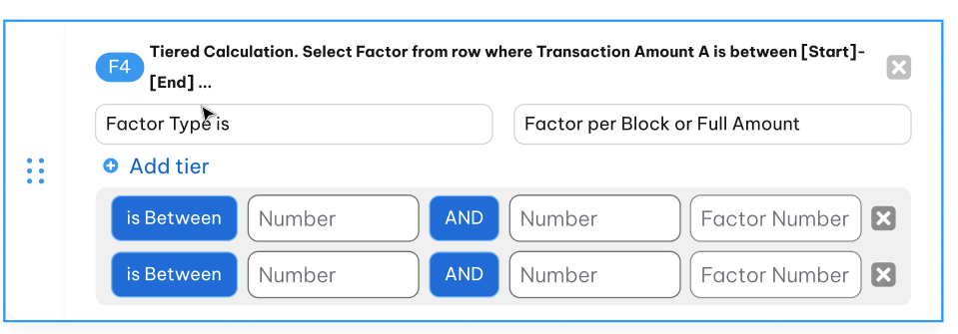
Selects one of two calculation algorithms as the Award Basis:
A. “Highest Tier in Which Amount Falls”
B. “Each Tier, applied to the part of Amount that Falls within that Tier”
- If Award Basis “A” is selected, and AF is a Percentage, then the AF in the highest Tier in which Amount falls is applied to the whole Amount, i.e. Result = AF x Amount, where AF is the AF of the highest Tier where Amount is greater than the lower bound but less than the upper bound).
- If “B” is selected, and if AF is a Percentage, then the AF for each Tier is applied to the part of Amount that falls within that Tier (AF x amount in Tier = D), and Result is the sum of D from all the applicable Tiers.
- If “A” is selected and AF is “Pool Units”, then the number of Pool Units awarded is AF as specified in the highest Tier in which Amount falls is applied to the whole Amount.
- If “B” is selected, and AF is “Pool Units”, then AF Pool Units are awarded for each Tier whose upper bound is less than Amount, i.e. Result = Sum AF of all Tiers with upper bound less than Amount.
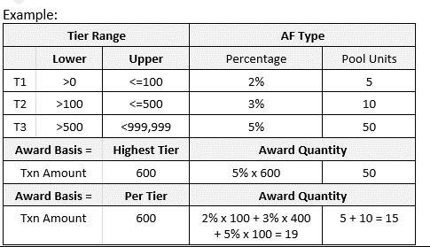

The finally result = Award points by Before Cap amount + Award points by after cap amount (if After Cap is available)

Formula 5
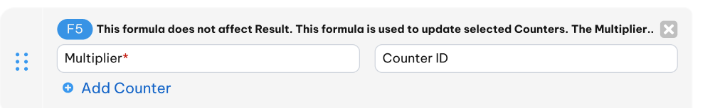
1. Counters are updated with an implicit value from the transaction context, depending on the Counter Definition – i.e. the Counter is updated with:
- Amount (spend counter)
- Formula Result (points counter) or
- Incremented by one (frequency counter), depending on the counter method selected in Counter Definition.
-The first input field accepts a number by which to multiply the amount to be added to Counter. If Multiplier is 0, the Counter value is set to 0.
Conclude: If transaction hit F5 then Counter value is updated:
Normal transaction: New counter value = Counter value + (F5 result * multiplier), except multiplier is 0
Reversal transaction: new counter value = Counter value - (F5 result * multiplier), except multiplier is 0

2. For point counter and point amount counter then:
Just update point counter/point counter value with the point /point amount form that Rule only. If there is no point but have F5 to update point counter then throw message to reject transaction.

Formula 6
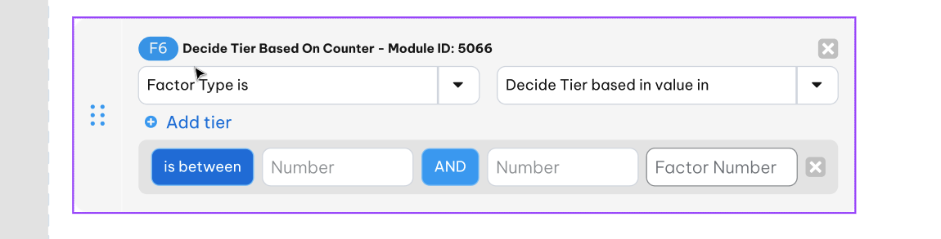
Formula 6 is for computation on a tiered basis, similar to Formula 4, but Formula 6 is different in that the tier is determined not by the Amount (as is the case in Formula 4), but instead it is by the value of a separately selected Counter.
“Decide Tier based in value in” is a drop-down to select all of 3 counter buckets: Current bucket/ Previous bucket/ before last bucket of each counter (in the next phase should support N bucket with N is configurable value by user). Based on “Effective Period Is Based On” of rule to determine counter value of Selected counter bucket.
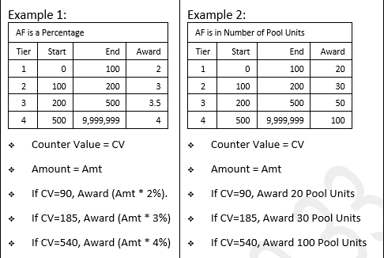

Formula 9
Update counter state

- “Counter” is drop-down list to select the counter to update counter state if transaction trigger CP rule.
- “Select state” is drop-down list to select the state to be updated.
There is 2 options to select “Next state” or “Previous State”. Depended in reversal indicator of transaction to process as following:
- Next State non reversal --> look for oldest C and update to A
- Next State reversal --> look for newest A and update to C
- Previous State non-reversal --> look for newest A and update to C
- Previous State reversal --> oldest C and update to A
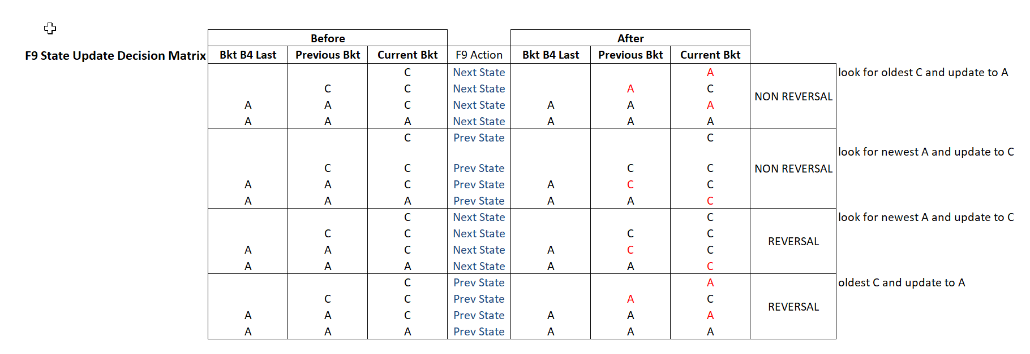

Formula 8
Update attribute value conditionally =tbd=

