Formula validation
Field | Description | Data type
Right panel | List all active formula on the system.  In the right panel, the list to selects a Formula to use. Each formula derives a Result which is used as the award quantity or the redemption quantity, depending on the Rule Type selected in the Rule Header. The supported formulae for deriving Result are:   Formula 1 – Add “P” to Result for every D of Amount   Formula 2 – Result = “P” (a fixed amount)   Formula 4 – Derive Result based on Amount Tier and a parameter “P”   Formula 5 – Update selected Counter   Formula 6 – Derive Result based on Counter Tier and a parameter “P”   Formula 7 – Derive Result based on Rate table   Formula 8 – Update Attributes   Formula 9 – Update State of selected Counter  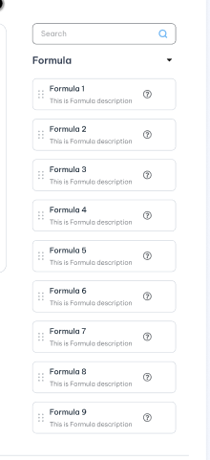 | View only
Drag/Drop formula | Allow user drag/drop the formula from right panel to set up rule.  Drag the selected Formula will be added as a panel for the edit and displaying the Formula parameters below the Formula part.  A Formula panel can be removed by clicking on the exit icon (X) in the panel header. | Action
Formula order | Formula Executing Seq.  It defaults to the ascending ordering sequence. User can re-arrange it if needed.  For example. If user select F1 and F5 then the default formula order must be F1=> F5 and user can re-arrange into F5=>F1.  The formula list is getting from “Code_Management”table where code type is “formula-list”. Refer “Get-by-code-type” API under Master data. | Action
Formula 1: Add [ N ] to Result for Every [ D ] Unit(s) of Transaction Amount, where Transaction Amount is the Gross Transaction Amount or Nett Transaction Amount as selected in Amount-To-Use, in Base Currency Units.

Only one formula 1 allow to configure on each campaign rule
If “Apply After Cap Value” button is on OFF
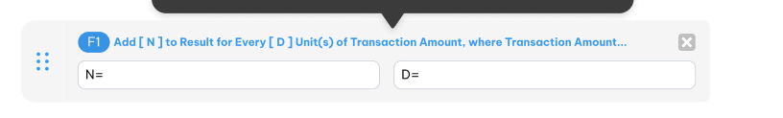
N | N value which apply for before cap  This is condition field. If “Apply After Cap Value” button is ON mode (apply after cap value logical ) then the field name should be “Before Amount Cap N” otherwise just “N”.  This is the number of pool units to add to Result for every D units of Amount in the “Block size” D.  If “Apply After Cap Value” button is on OFF mode then this field is required.
D | The block size of transaction Amount before cap.  If “Apply After Cap Value” button is on OFF mode then this field is required.
If “Apply After Cap Value” button is on ON
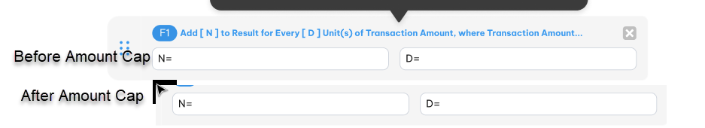
Before Amount Cap N | N value which apply for before cap  This is condition field. If “Apply After Cap Value” button is ON mode (apply after cap value logical) then the field name should be “Before Amount Cap N” otherwise just “N”.  This is the number of pool units to add to Result for every D units of Amount in the “Block size” D. | 9(14,2)  Allow positive value only
D | The block size of transaction Amount before cap. | 9(14,2)  Allow positive value only
After Amount Cap N | N result apply for after Cap value  This is condition field. If “Apply After Cap Value” button is ON mode (apply after cap value logical) then this field is active. | 9(14,2)  Allow positive value only
D | The block size of transaction amount after cap.  This is condition field. If “Apply After Cap Value” button is ON mode (apply after cap value logical) then this field is active. | 9(14,2)  Allow positive value only
Formula 2: Add [ N ] to Result
Only one formula 2 allow to configure on each campaign rule
N* | “N” is the number of Pool Units to add to “Result” for every transaction meeting criteria in this Rule. | 9(14,2)
Formula 4: Tiered Calculation. Select Factor from row where Transaction Amount A is between [Start]-[End] in that row. If Percent is chosen in the corresponding drop-down box, then add (Factor XA) to Result. If Points is selected, then add Factor to Result
Factor Type is */Loại hệ số | This specifies whether “Award Factor” (AF) is a Percentage or a quantity of “Pool Units”. Drop-down selects “Award Factor” or “Pool Units”. | Drop-down  Select one  Lookup value from “Code_Management” table where code type is “factor-type”  Refer “get-by-code-type” API under master data
Factor per Block or Full Amount*/Hệ số theo mỗi khối hay trên toàn bộ giá trị | Selects one of two calculation algorithms as the Award Basis:  A. “Highest Tier in Which Amount Falls”  B. “Each Tier, applied to the part of Amount that Falls within that Tier | Drop-down  Select one  Lookup value from “Code_Management” table where code type is “f4-factor-option”.  Refer “get-by-code-type” API under master data
Add tier | Edit row for specifying formula parameters for a Tier, i.e. the range of values in a Tier and the corresponding AF value.  - Click to add button to add new tier. Up to 10 tiers can be defined.  - If “Apply After Cap Value” button is on OFF mode.  When the “+” icon is clicked, the parameters in the edit row are added to the display area below the edit as a row, as following illustrated :  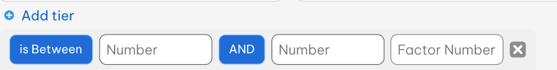  Each record includes:  - If “Apply After Cap Value” button is on ON mode.  When the “+” icon is clicked, the parameters in the edit row are added to the display area below the edit as a row, as following illustrated :  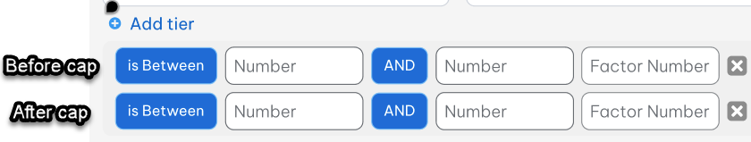 | Button
  Field | Descriptions | Data type
  Is between * | is a number field specifying the lower bound (exclusive) of the Tier. | 9(14,2)  Should be greater than or equal 0.  For first tier it is entered by user  For next tier it should be automation updated as “AND” value of previous tier plus 0.01 and don’t allow user edit this one.
  And * | The second input field is a number field specifying the upper bound (inclusive) – e.g. “>0” and “<=100” are the lower bound (exclusive) the upper bound (inclusive) of the first Tier respectively. | 9(14,2)  Positive value only  “and” must be greater than “is between” value.
  Factor* | The third input field is a number specifying AF. | 9(14,2)  Positive value only
  Field | Descriptions | Data type
  Before Cap
  Before Cap | The label is only active when on Apply after cap mode. | Label  Display
  Is between | This is a number field specifying the lower bound (exclusive) of the Tier. | 9(14,2)  Positive value only  For first tier it is entered by user  For next tier it should be automation updated as “AND” value of previous tier plus 0.01 and don’t allow user edit this one.
  And | The second input field is a number field specifying the upper bound (inclusive) – e.g. “>0” and “<=100” are the lower bound (exclusive) the upper bound (inclusive) of the first Tier respectively. | 9(14,2)  Positive value only  “and” must be greater than “is between” value.
  Factor | The third input field is a number specifying AF. | 9(14,2)  Positive value only
  After cap: This row is active on each tier when Apply after cap only
  After cap | The label is only active only when on Apply after cap mode. | Label  Display
  Is between | This is a number field specifying the lower bound (exclusive) of the Tier. | 9(14,2)  Positive value only  For first tier it is entered by user  For next tier it should be automation updated as “AND” value of previous tier plus 0.01 and don’t allow user edit this one.
  And | The second input field is a number field specifying the upper bound (inclusive) – e.g. “>0” and “<=100” are the lower bound (exclusive) the upper bound (inclusive) of the first Tier respectively. | 9(14,2)  Positive value only  “and” must be greater than “is between” value.
  Factor | The third input field is a number specifying AF. | 9(14,2)  Positive value only
Formula 5
Multiplier*/Hệ số nhân | Input field accepts a number by which to multiply the amount to be added to Counter. If Multiplier is 0, the Counter value is set to 0. | 9(14,2)  Should be greater than or equal 0
Counter ID */Bộ đếm | The input field is a drop-down for selecting the Counter to update.  Note that Counters are updated with an implicit value from the transaction context, depending on the Counter Definition – i.e. the Counter is updated with  - Amount (spend counter)  - Formula Result (points counter) or  - Incremented by one (frequency counter),  depend on the counter method selected in Counter Definition.  Each counter is assigned to only one F5 per each campaign rule. | Drop-down  Select one  Refer “Counter Definition” API under Campaign management
Add counter | After the fields in this row have been filled in, the “+ Add counter” icon is active, and when it is clicked will add the details from the input fields in the display area as a new row. | Button
Formula 6
Factor Type is */ Loại hệ số là | This specifies whether “Award Factor” (AF) is a Percentage or a quantity of “Pool Units”. Drop-down selects “Award Factor” or “Pool Units”. | Drop-down  Select one  Lookup value from “Code_Management” table where code type is “factor-type”  Refer “get-by-code-type” API under master data
Decide Tier based on value in*/ | The input box is a drop-down for selection of a Counter to be used for determining the AF to use in deriving Result.  This drop-down allow to select all of 3 counter buckets: Current bucket/ Previous bucket/ Before last bucket of each counter.  E.g : Current -Counter Name [Counter ID]  Previous – Counter Name [Counter ID]  Before last – Counter Name [Counter ID] | Drop-down  Select one  Lookup value from “Counter_Definition” table  Refer “get-by-code-type” API under master data
Add Tier /Thêm | Edit row for specifying formula parameters for a Tier, i.e. the range of values in a Tier and the corresponding AF value.  - Click to add button to add new tier. Up to 10 tiers can be defined.  When the “+” icon is clicked, the parameters in the edit row are added to the display area below the edit as a row, as following illustrated :  Each record includes: | Button
  Field | Descriptions | Data type
  Is between * | The first input field is a number field to enter the lower bound of a Tier. | 9(14,2)  Positive value only  For first tier it is entered by user  For next tier it should be automation updated as “AND” value of previous tier plus 0.01 and don’t allow user edit this one.
  And * | The second input field is a number fields to enter the upper bound of a Tier | 9(14,2)  Positive value only  “and” must be greater than “is between” value.
  Factor* | The third input field is a number field specifying the value of AF, which is either the number of Pool Units to award or the percentage of Amount to award in Pool Units | 9(14,2)  Positive value only
Formula 9
Allow Only one formula 9 per each campaign rule
Counter Id*/ Bộ đếm | The “Counter” drop-down field lists all valid Counters as defined in Counter Definition. | Drop-down  Select one  Lookup value from “Counter_Definition” table.  Refer “Campaign Counter Definition” API under Campaign management.
Select State */Chọn trạng thái | The “Next State” drop-down provides the following choices:  “Next State” , which will update the State as follows:  If the State before update is “C”, the State will be updated to “A”  If the State before update is “A”, the State will be updated to “O”  If the State before update is “O”, no action is taken (Counter State is not changed) | Drop-down  Select one  Lookup value from “Code_Management” table where code type is “f9-counter-sate”.  Refer “get-by-code-type” API under master data.
Formula 8: Please consider and advise to change UI/UX for this
Following items are explained for existing version

Attribute group/Nhóm thuộc tính | Group of attribute | Drop- down  Select one
Attribute ID*/ Thuôc tính | Attribute ID to update attribute value/expire date  If Attribute group is selected then just list all attribute of selected atrribute group  If attribute group is not selected then list all active attribute on the system. | Drop-down  Select one  Lookup value “Attribute_Definition” table.  Refer “Attribute Definition” API under Code Maintenance
Condition | After an Attribute has been selected, depending on the data type of the Attribute, condition appear to allow input of the conditional arguments as illustrated in the following figures  Bellow image shows the a Date Attribute has been selected in the selection row :  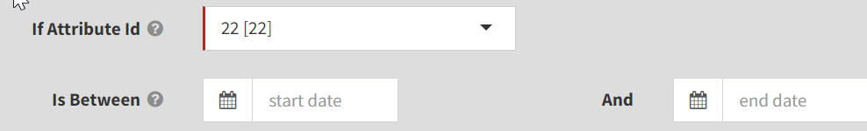  Bellow image shows a boolean attribtue has been selected in the seclection row:  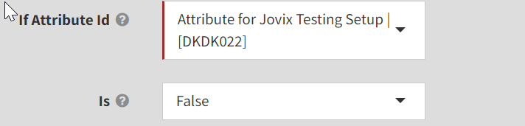  Bellow image show a character attribute has been selected in the selection row  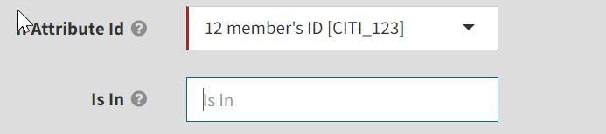  Bellow image show a character attribute has been selected in the selection row  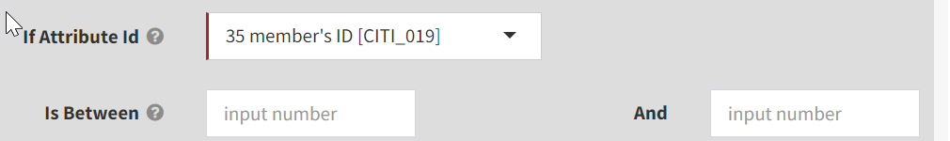
Set * | Attribute ID need to be updated attribute value | Drop-down  Select one  Lookup value from “Attribute_Definition” table.  Refer “Atrribute Defintion” API under code maitenance
Set to value | Value is depened on selected "Data type":  - if "Boolean" data type is selected then swith button true/false is actived for default value field. Default False.  - If "Character" datatype is selected then a textbox is actived for default value.  - If " Date" datatype is selected hen a Date field is actived for default value field.  - If "Number" datatype is selected then a Numberic filed (double data type) is actived for default value fied.
Expiring | 2 choices for user:  1) User can enter a fixed date (1st input field) (Expiring )  or  2) user can enter N followed by the drop-down choice of "End of Month" or "End of Quarter" (Set Expiry Date to).  if user enters a Fixed Date, we update the Expiry Date = value (Fixed Date) entered  if user select period we update the expire date into selected period  - Admin screen allows only choice of FIXED DATE or N [Period Unit]. If Expiring is provided then “Set Expire Date to “ is inactived and vice versa.  - If “Set Expire Date To “ is selected and “Period is not No Expire / Post Date “ then “N” field is actived.  - Have to choose at least one option: Fixed or period type
Set Expire Date to |  | Drop -down  Select one  Refer “get-by-code-type” API under master data with code type is “
N |  | 9(2)

